**Name________________________________________ Classroom__________________**

**Elbow Lane Practicum**

**Elbow Lane Orientation**

* What is the director’s name?_____________________________
* How do you become an early childhood educator? What are the requirements?
* How long has Elbow Lane been in operation? _____________________________
* What are the hours of operation? _____________________________
* How much does it cost? _____________________________
* What are you looking forward to most about going to Elbow Lane?

**Elbow Lane Grade Sheet**

**Elbow Lane Packet Points**

__________/15 Points: Physical/Intellectual Development Observation

__________/15 Points: Emotional/Social Development Observation

__________/50 Points: Children’s Book Assignment

__________/15 Points: Elbow Lane Evaluation

__________/5 Points: Elbow Lane Reflection

**__________/100 Points**

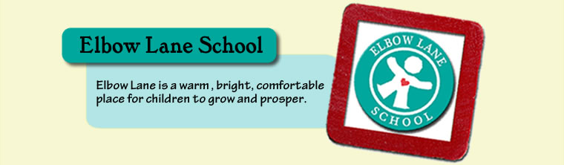

**Comments:**

**Elbow Lane Participation Points**

**__________/40 Points**

*If you missed a trip – please complete make-up assignment*

**Name________________________________________ Classroom__________________**

**Physical Development Observation**

1. Describe the physical development of a child in your classroom.
2. Are the children all the same height and weight? Explain the differences.
3. What activities are the children doing that are helping with their physical development? (Name and Describe Two)

**Intellectual Development Observation**

1. Explain an activity that the children are participating in today that will enhance their intellectual development.
2. What items are on the walls or what games, toys, or puzzles are in the classroom that could help with intellectual development? Make a list.
3. You must participate in at least 2 activities with the children. Describe the activities and what you did.

**Name________________________________________ Classroom__________________**

**Emotional/ Social Development Observation**

1. Name three emotions you observed today with the children. Explain each situation.
2. How do the children handle their feelings/emotions?
3. What are the teachers doing to help the children to understand their feelings/emotions?
4. What are some of the activities the children are enjoying together?
5. How do the children communicate and interact with each other? Give both positive and negative examples.

**Name________________________________________ Classroom__________________**

**Children’s Book Evaluation**

**Name of Book _______________________________________________**

**Elbow Lane Teacher Name __________________________________**

***Elbow Lane Teacher*** *evaluates student’s performance using the score sheet below:*

|  |  |  |
| --- | --- | --- |
| **CRITERIA** | **Possible Points** | **Points Earned** |
| ***Book/story***  Book/story is suitable for the age of children (DAP) | 5 |  |
| Story made sense and was creative | 5 |  |
| Illustrations are colorful and matched storyline | 5 |  |
| Good grammar, proper spelling | 5 |  |
| Book is neat, creatively done, and is reusable | 5 |  |
| ***Reading***  Introduction captures children’s attention | 5 |  |
| All children can see the book | 5 |  |
| Enthusiastic/expressive voice and pauses used effectively | 5 |  |
| Children involved during the story | 5 |  |
| Definite conclusion: Events of the story highlighted | 5 |  |
| **TOTAL POINTS** | **50** |  |

*Elbow Lane Teacher’s Comments/Suggestions:*

**Name________________________________________ Classroom__________________**

**Elbow Lane Teacher: Student Evaluation**

***Elbow Lane Teacher*** *evaluates CB student’s performance/participation throughout their experience at Elbow Lane using the score sheet below:*

**ELBOW LANE TEACHER NAME_____________________________________________________________**

|  |  |  |
| --- | --- | --- |
| **Student Evaluation** | **Possible Points** | **Points Earned** |
| Student interacted/communicated with you and the students effectively | 3 |  |
| Student showed genuine interest in children | 3 |  |
| Student participated in various activities with children | 3 |  |
| Student behaved appropriately while in your classroom | 3 |  |
| Student’s overall presence, attitude, helpfulness, preparation, etc in your classroom | 3 |  |
| **TOTAL POINTS EARNED** | **15** |  |

Use the space below to provide any necessary feedback or comments about the student’s performance/participation in your classroom:

**Elbow Lane Reflection**- completed by CB student

1. What is the most important thing you learned about the development of young children through your time spent at Elbow Lane?
2. Would you consider a future career working with young children? If so, what would you like to do and why? If not, why- what else interests you for your future?